

**MINI PROJECT – 1:**

**Hosting a website on AWS EC2 Instance with Auto Scaling group, Application Load Balancer, Monitor with Cloud Watch and Add Simple Notification Service (SNS) for it.**

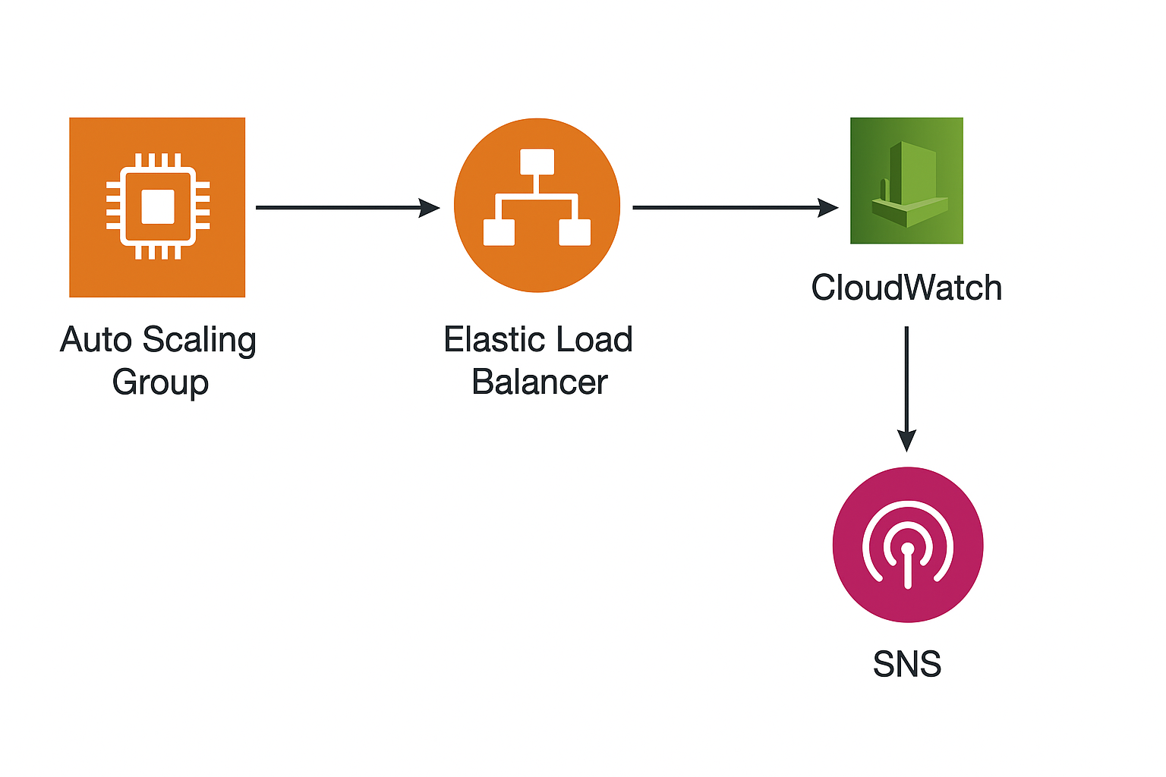

**PROJECT OVERVIEW:**

This project demonstrates how to deploy a scalable and highly available web application using Amazon Web Services (AWS).

**The architecture uses:**

* **EC2 Instances:** To host the website/application.
* **Launch Template:** To configure Auto Scaling EC2 instances.
* **Auto Scaling Group (ASG):** To scale instances automatically based on demand.
* **Application Load Balancer (ALB):** To distribute traffic across instances.
* **Amazon CloudWatch:** For monitoring instance metrics and logs.
* **Amazon SNS:** To send email/SMS alerts based on CloudWatch alarms.

**CREATE LAUNCH TEMPLATE:**

**STEP 1: Create Launch Template.**

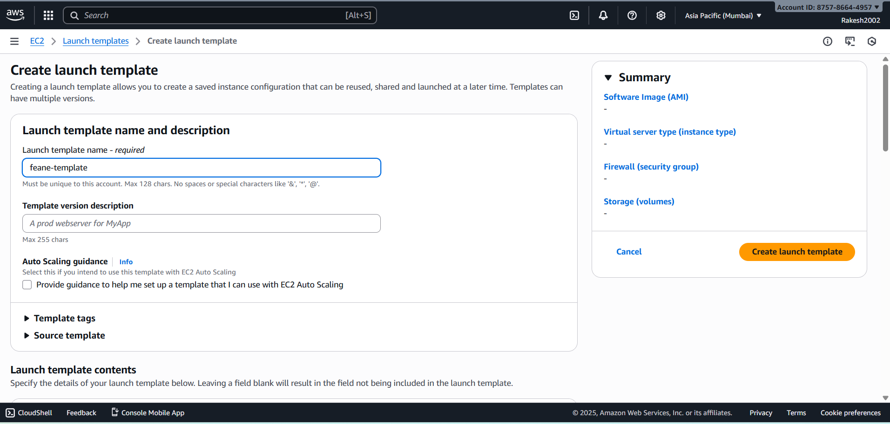

**STEP 2:** **Add user data in template**.

* Add web server(apache2)
* Download the website code file in it.
* Unzip the code file.

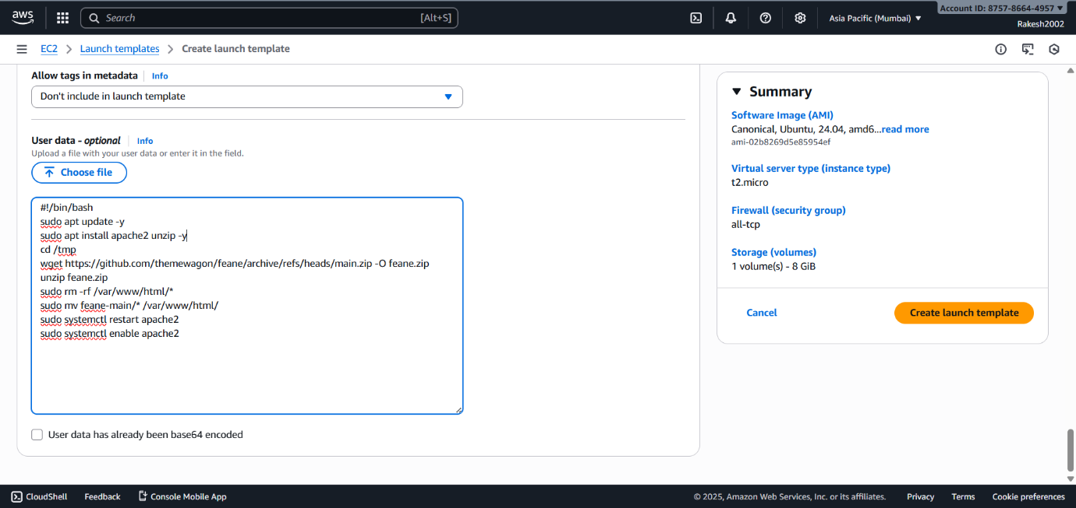

**CREATE AUTO SCALING GROUP FROM LAUNCH TEMPLATE.**

**STEP 3:** **Create Auto scaling Group.**

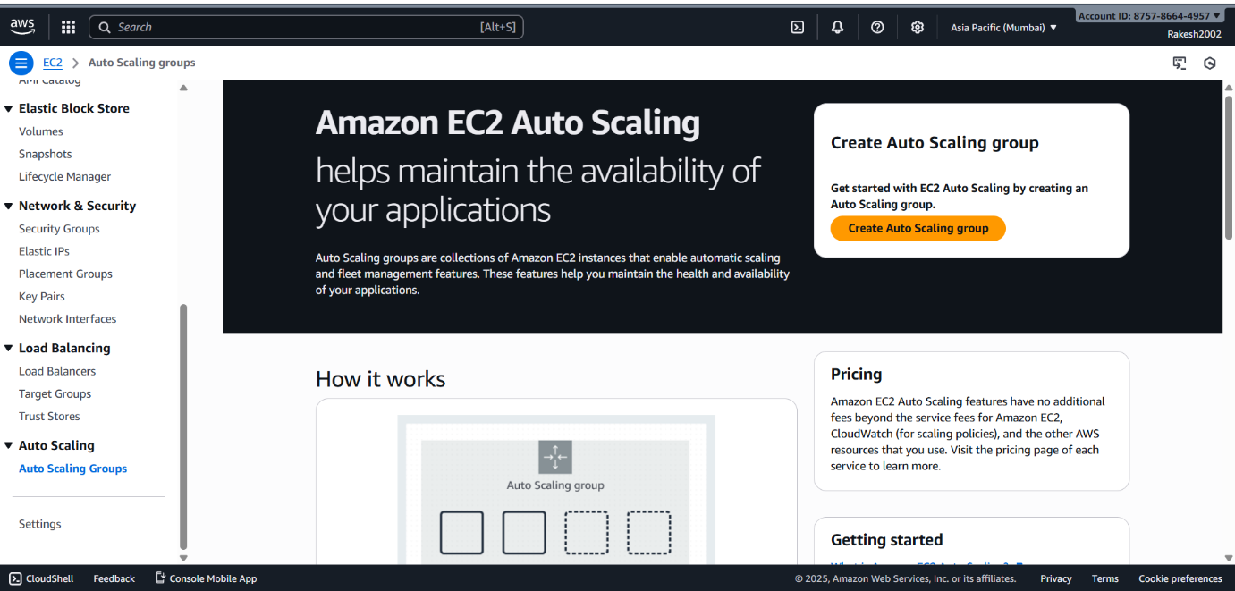

**STEP 4:** **Define name and template.**

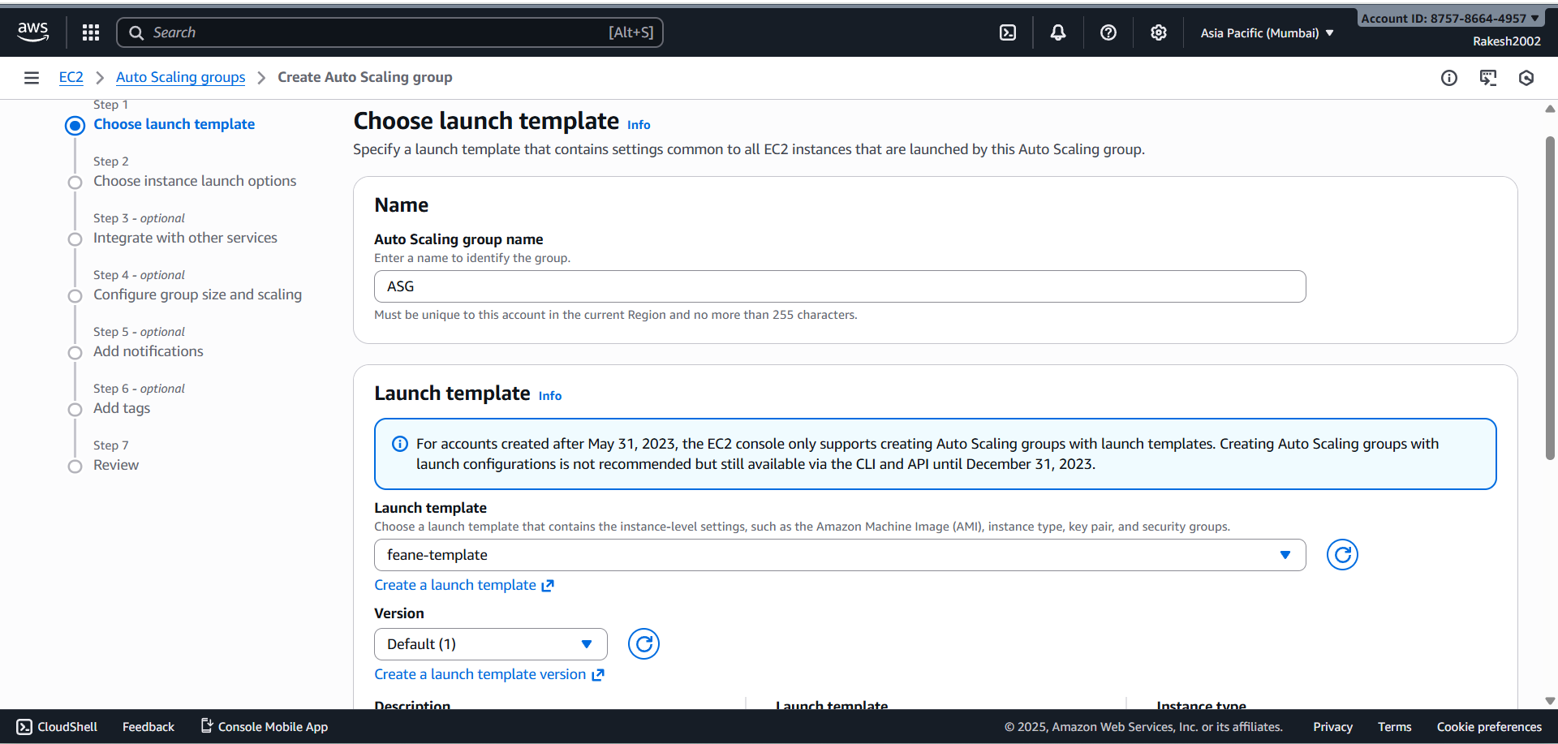

**STEP 5: Choose instance launch options.**

* Select availability zones and subnets.

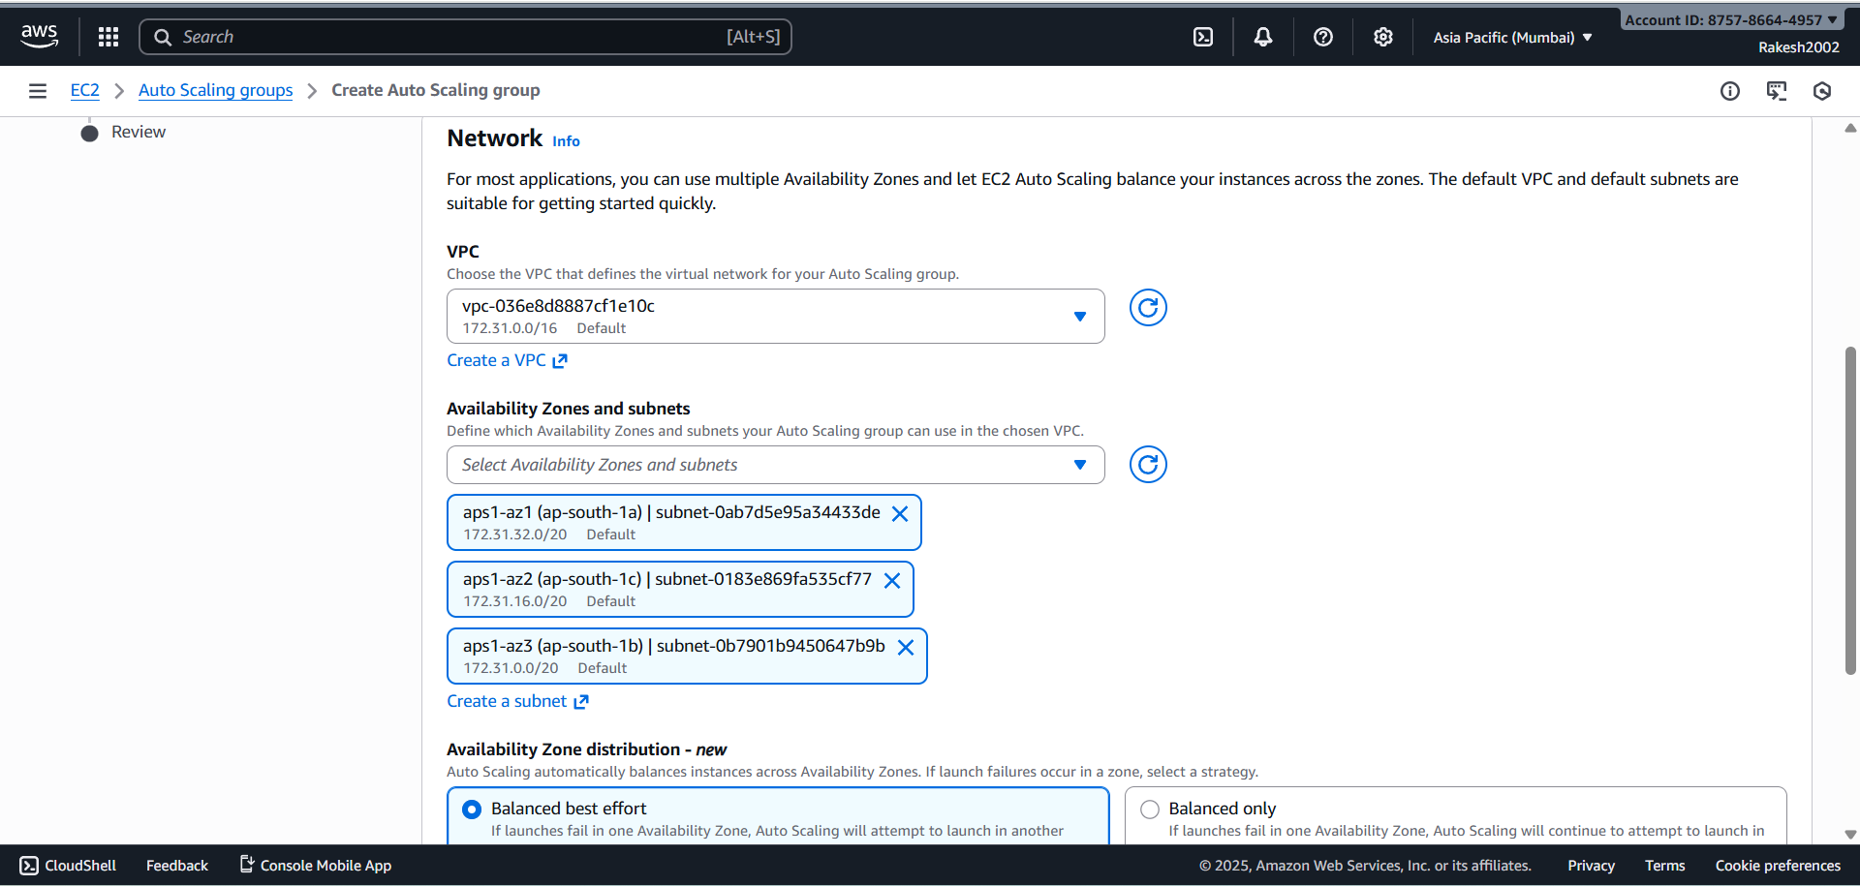

**STEP 6:** **Configure advanced options.**

* Add application Load balancer option.

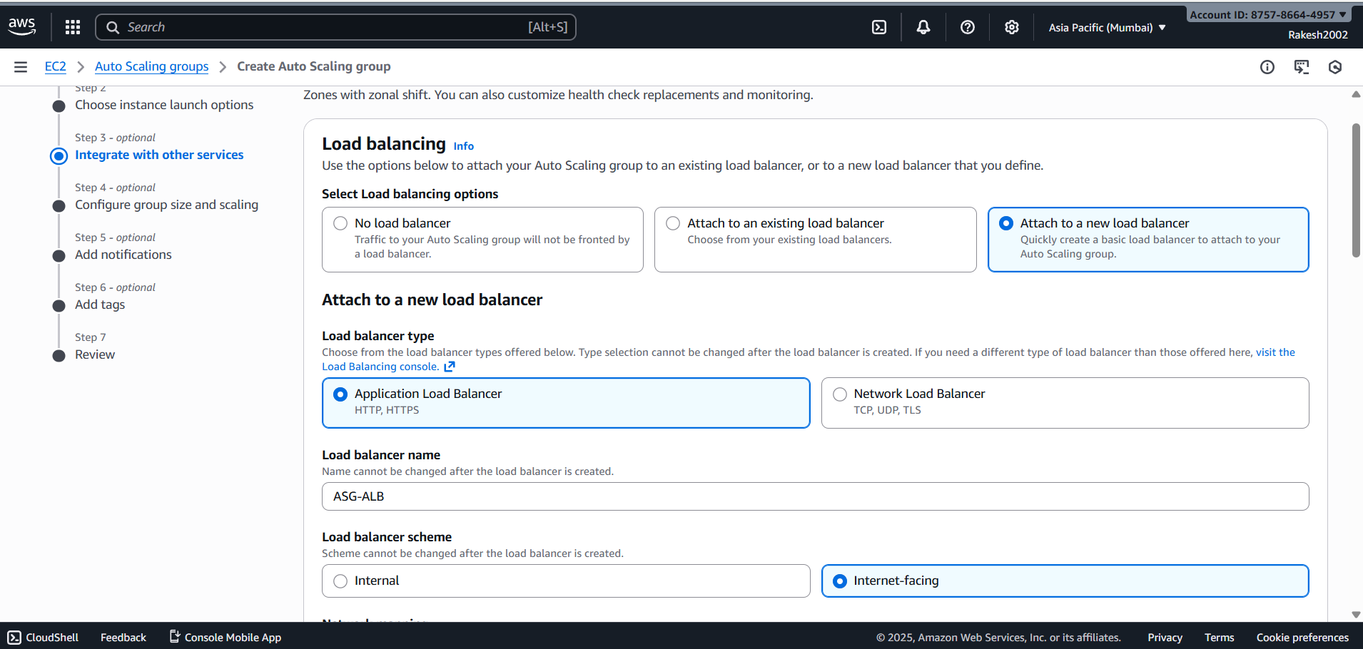

**STEP 7: Add load balancer and target group.**

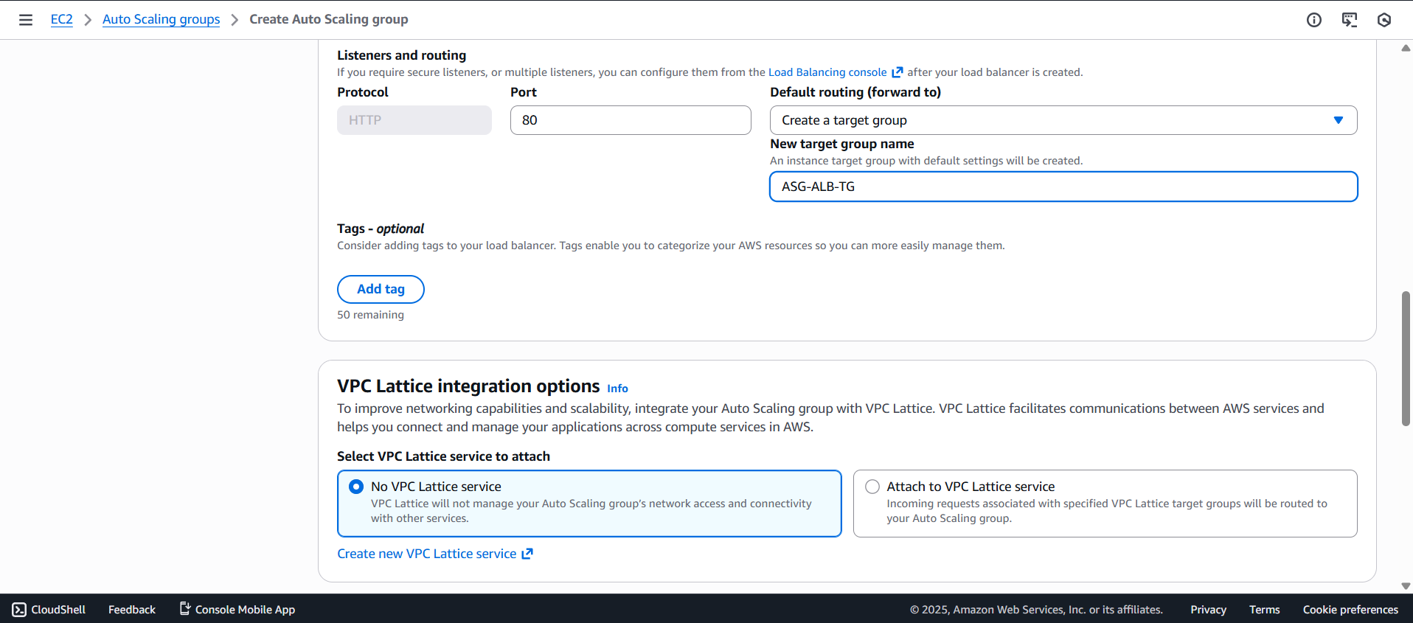

**STEP 8:** **Configure group size and scaling.**

* Select the minimum, desired and maximum capacity.

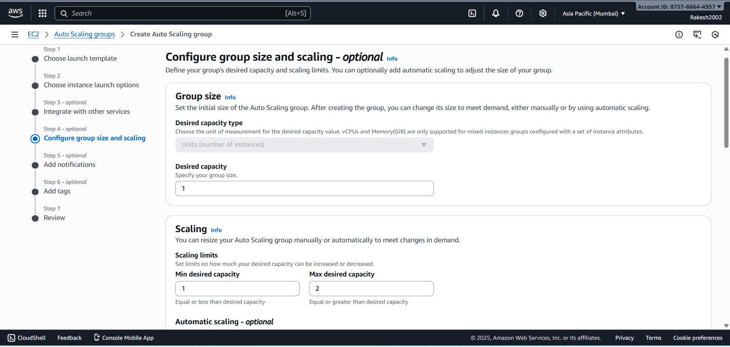

**STEP 9:** **Add Notification.**

* Create a new topic.
* Enter name and endpoint user email.

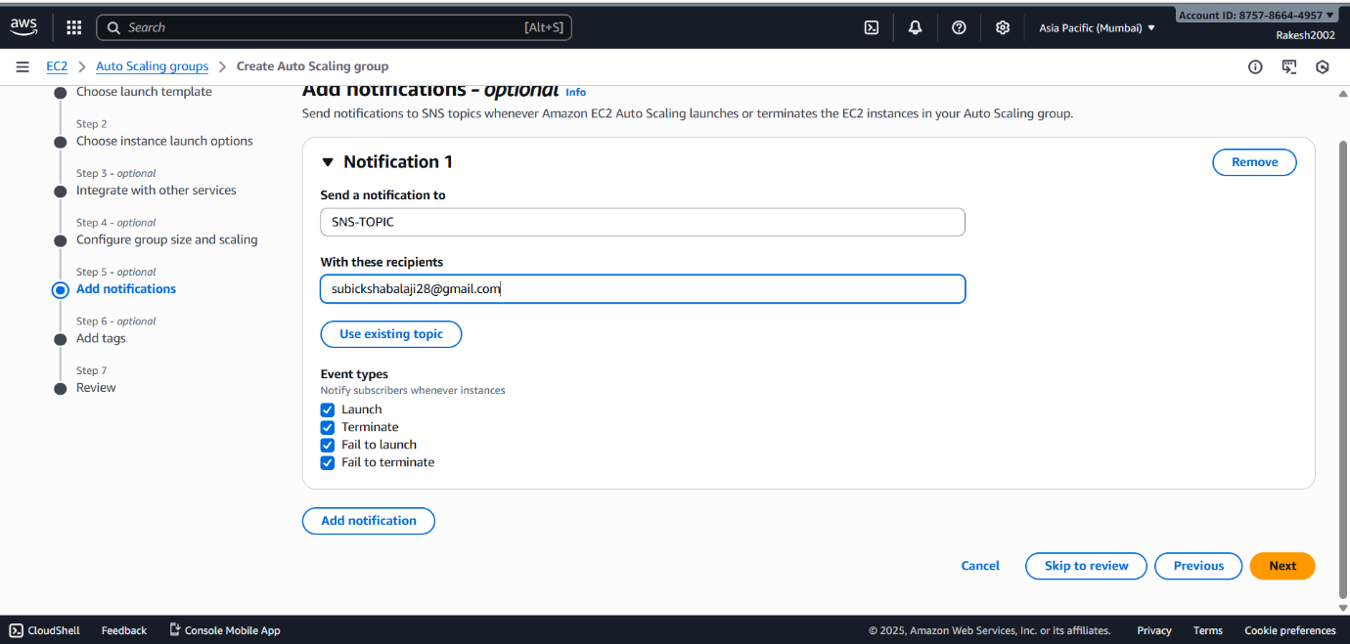

**STEP 10:** **Add tags and review.**

* Click on create Auto Scaling groups.

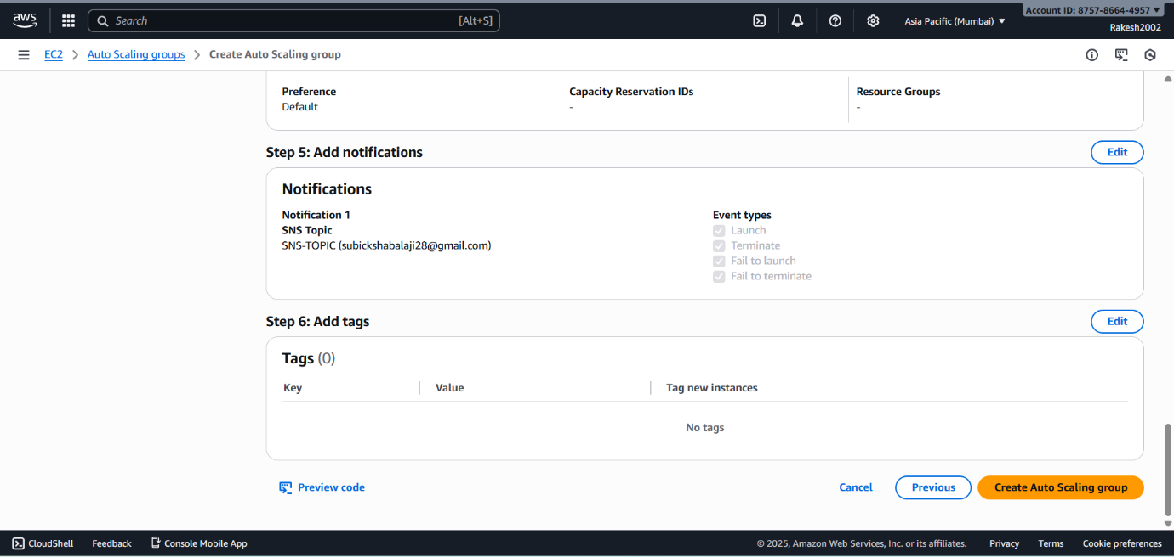

**STEP 11: New Autoscaling Group is created.**

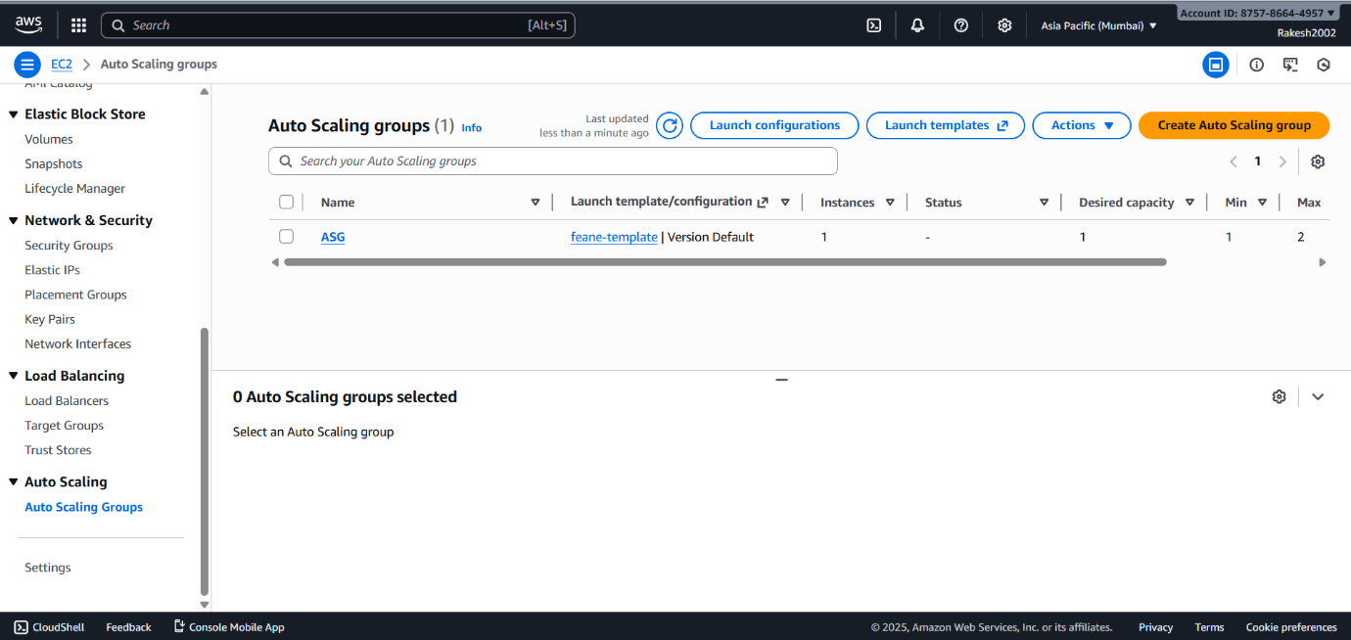

**STEP 12: New Instance is automatically created.**

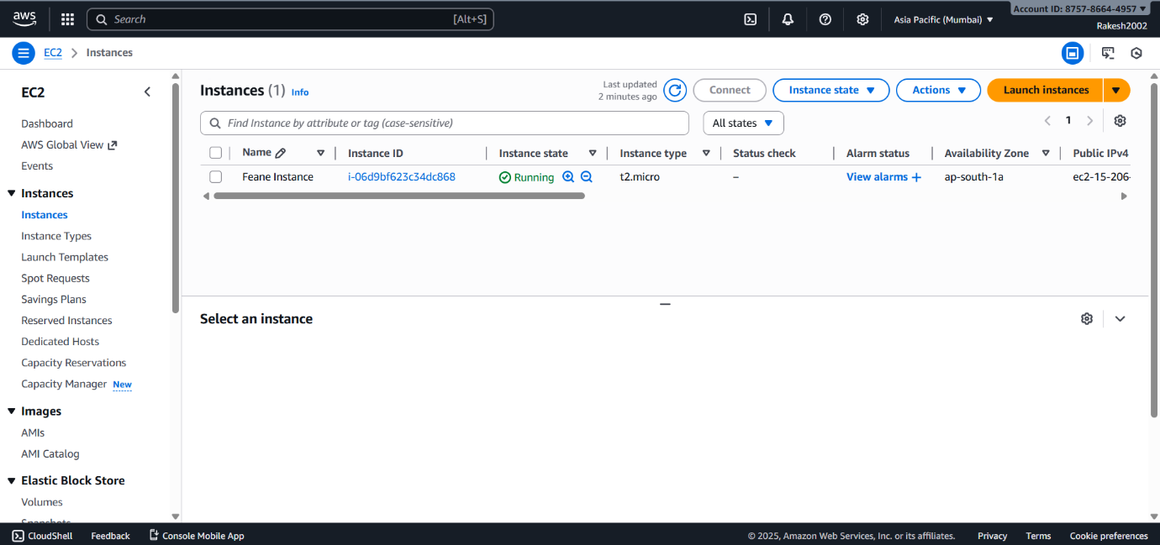

**STEP 13:** **New target group is automatically created.**

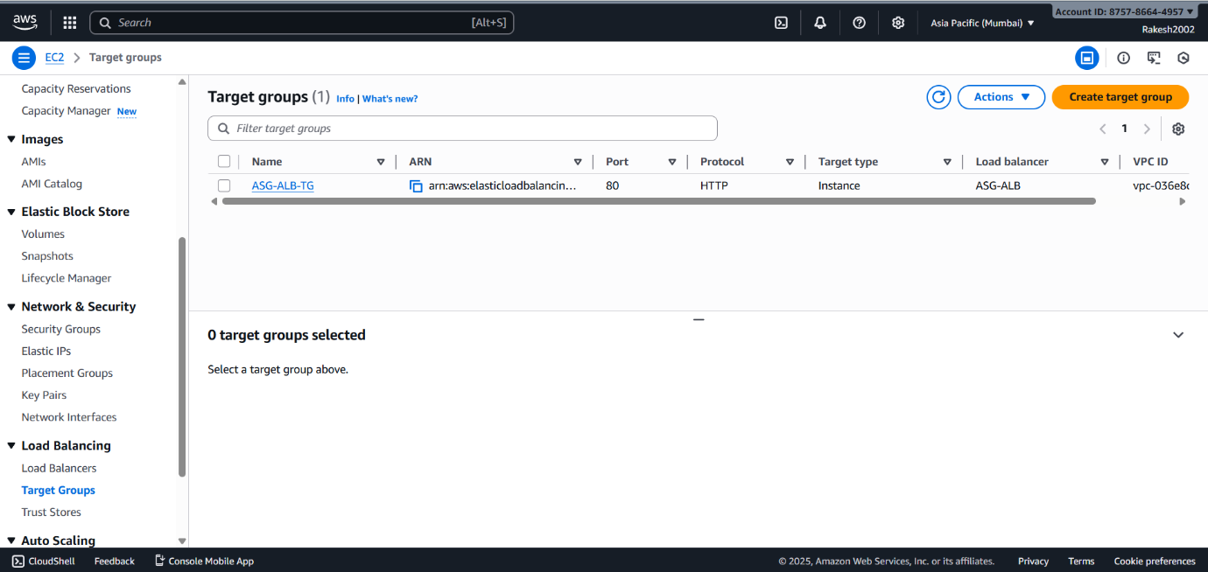

**STEP 14:** **New Application Load Balancer is automatically created.**

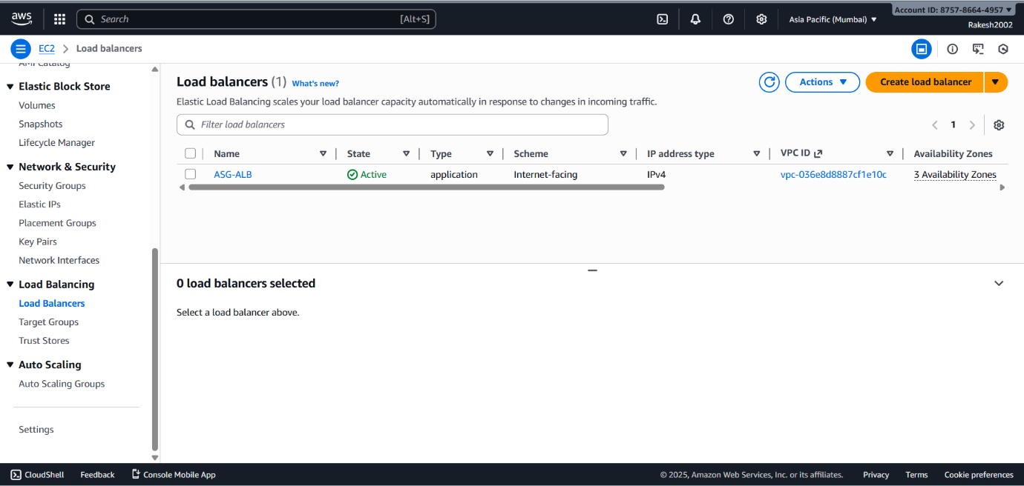

**STEP 15:** **Check Simple Notification Service (SNS)**.

* New topic and subscription are created.

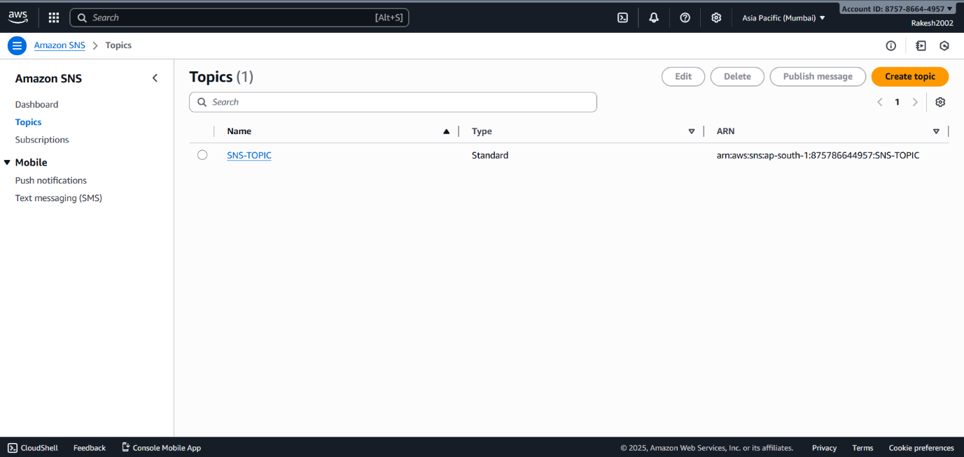

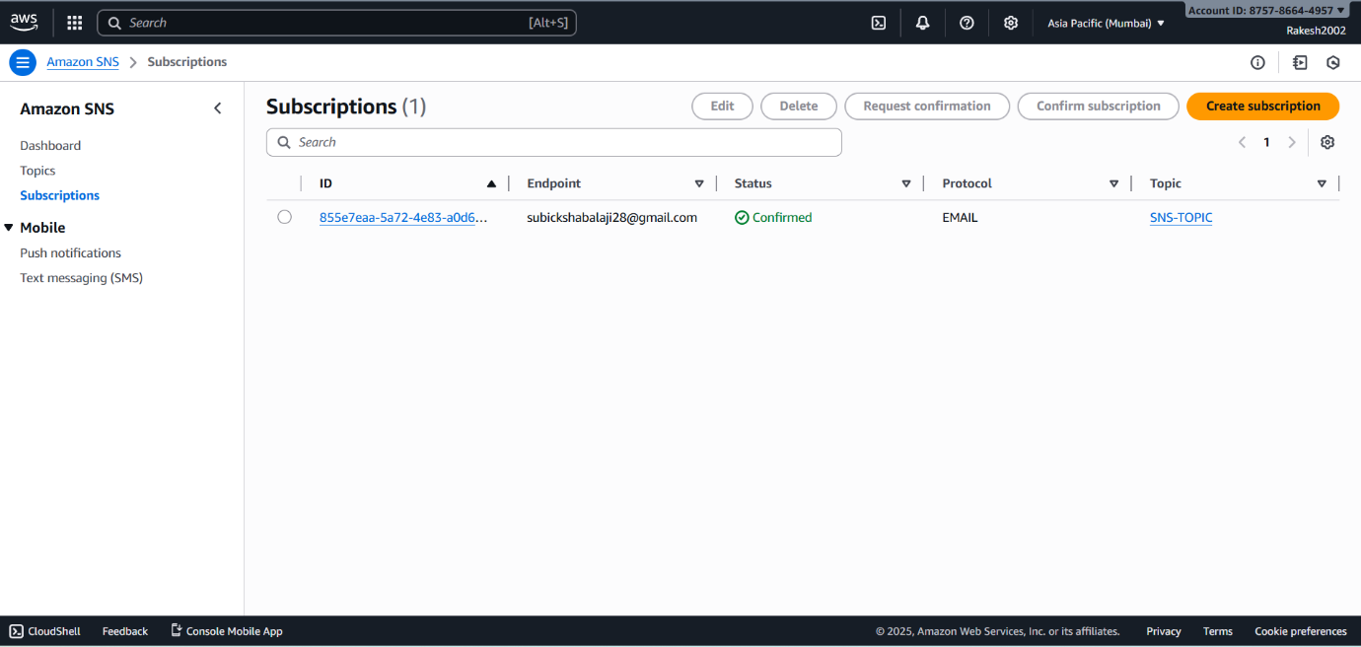

**STEP 16:** **Confirm subscription email.**

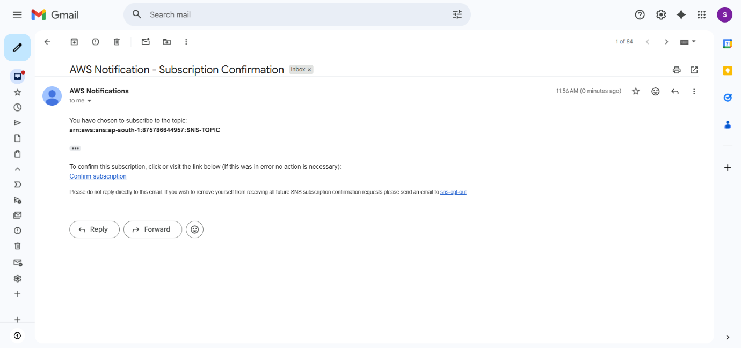

**ADD CLOUD WATCH: MONITOR THE SYSTEM SERVICES FROM THE CLOUD WATCH.**

**STEP 17**: **Create a dashboard.**

* Define the name to dashboard.

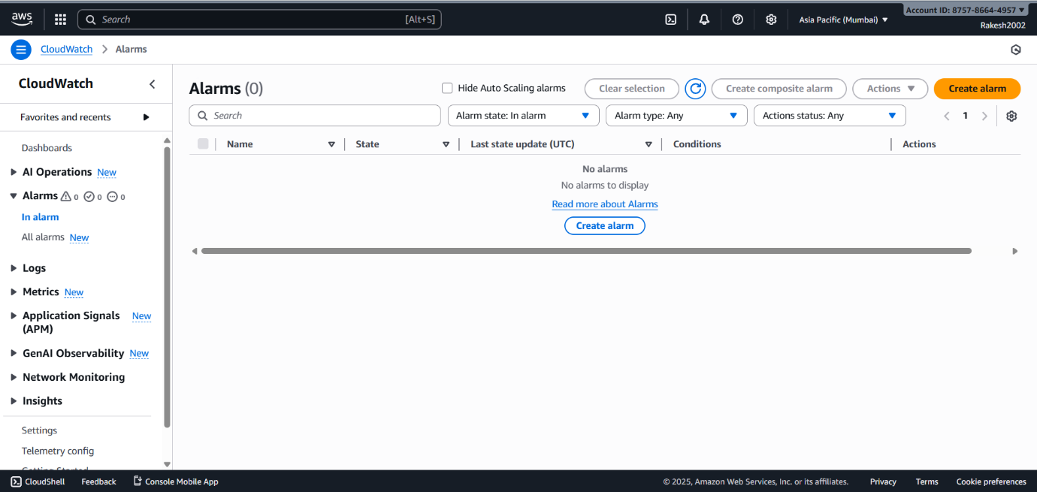

**STEP 18**: **Select metric.**

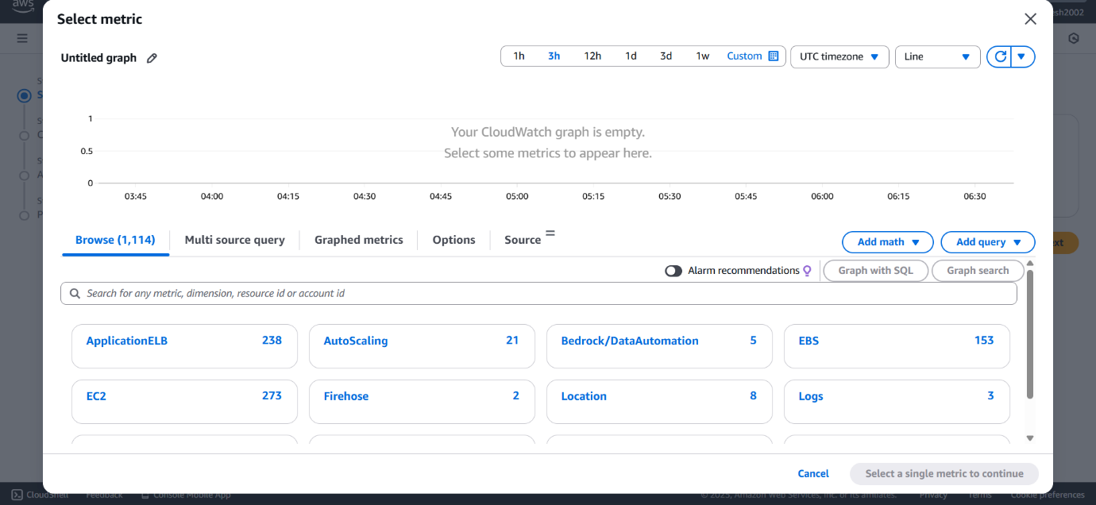

**STEP 19:** **Specify metric and conditions.**

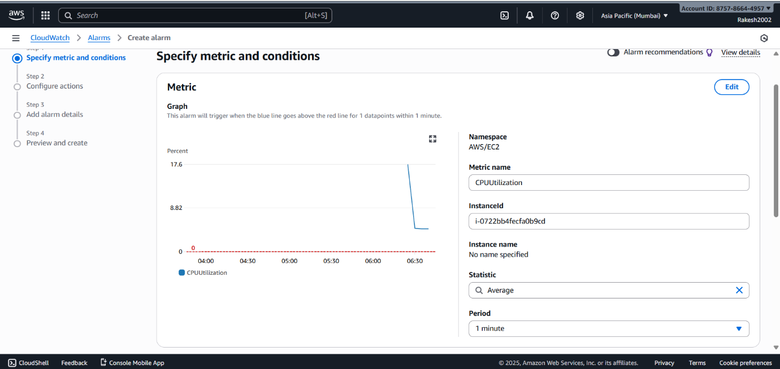

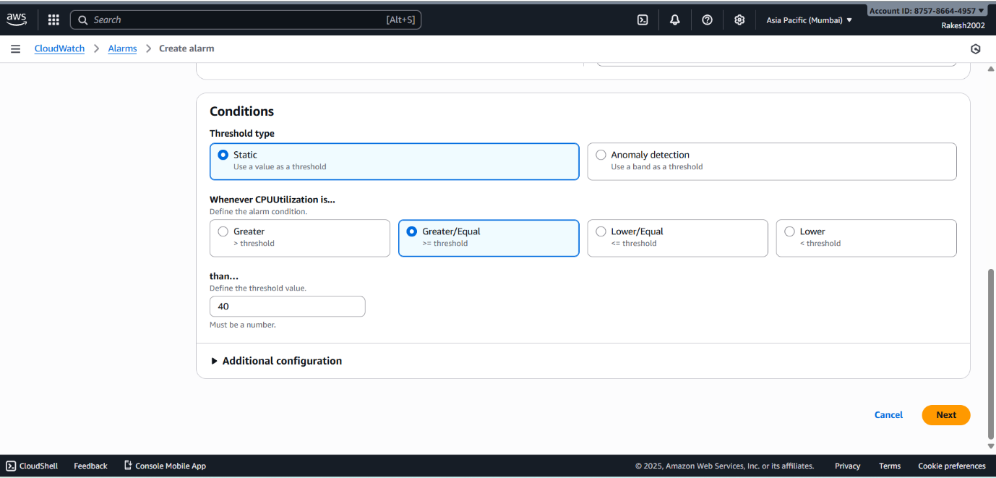

**STEP 20: Configure actions.**

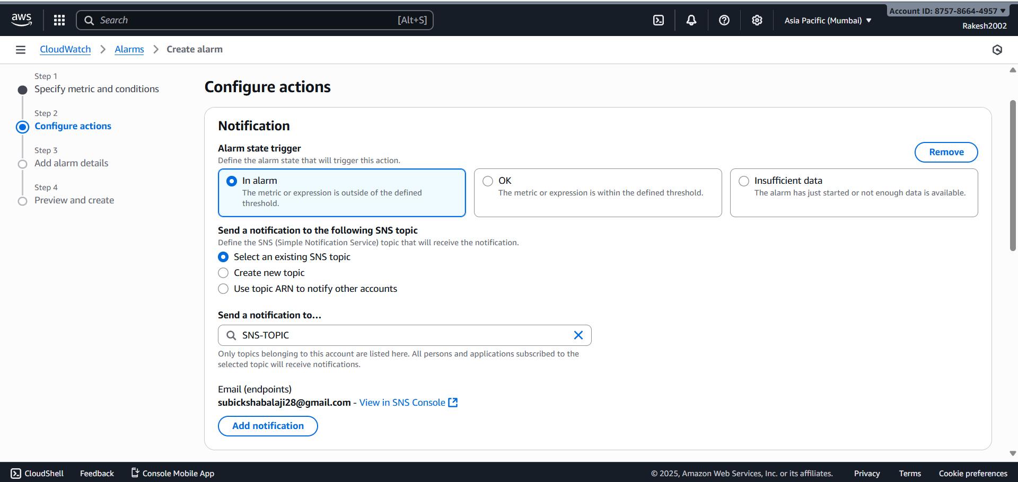

**STEP 21:** **Add alarm details.**

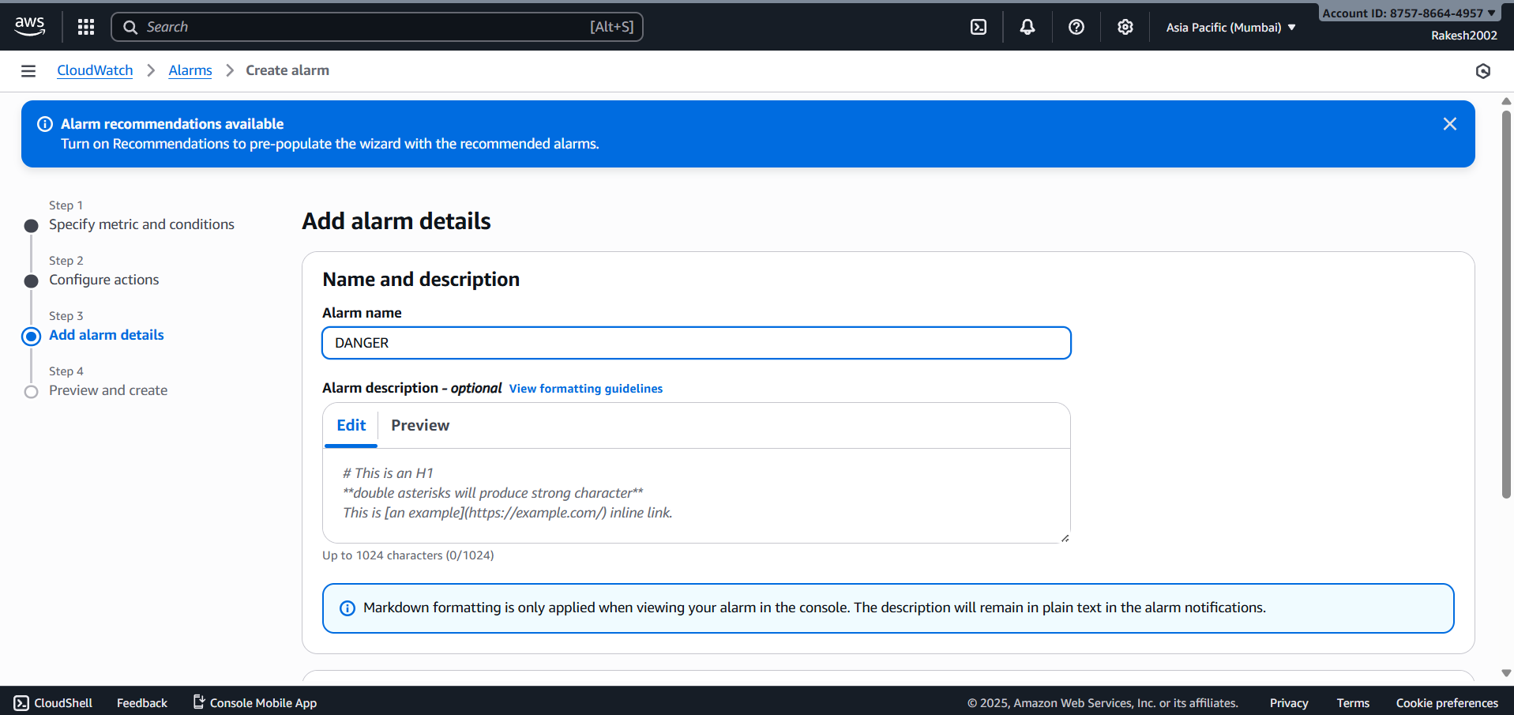

**STEP 22:** **Preview and create.**

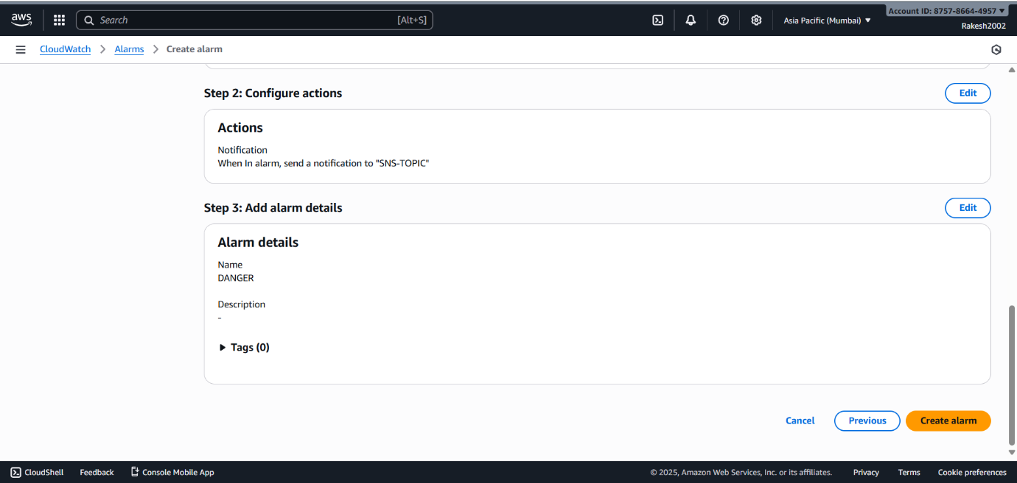

**STEP 23:** **Cloud watch alarm is created.**

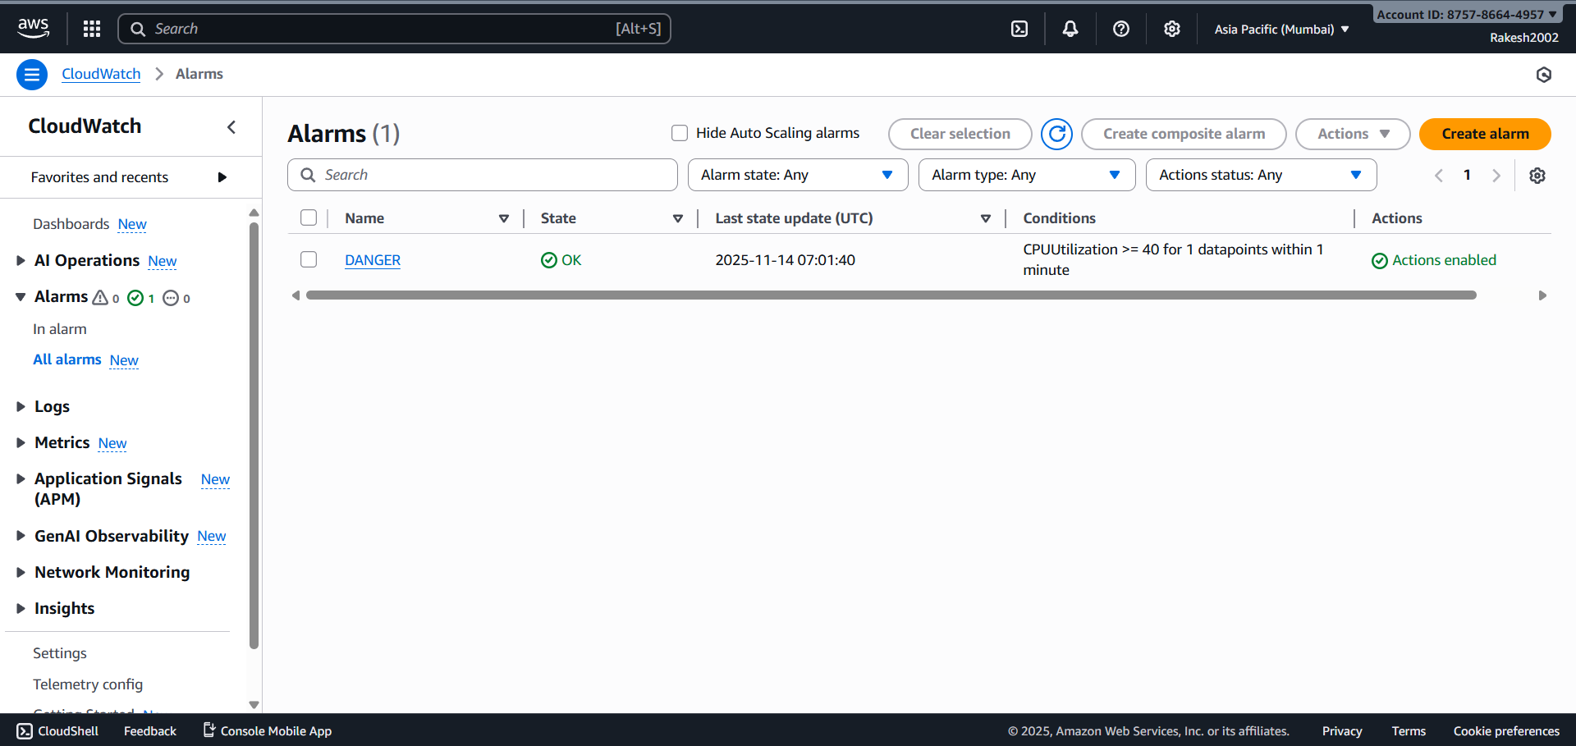

**STEP 24: Go to Autoscaling group.**

* Click Autoscaling Group.
* Choose Automatic Scaling.
* Click Create Dynamic Scaling Policy to attach Cloud watch alarm with Autoscaling Group.

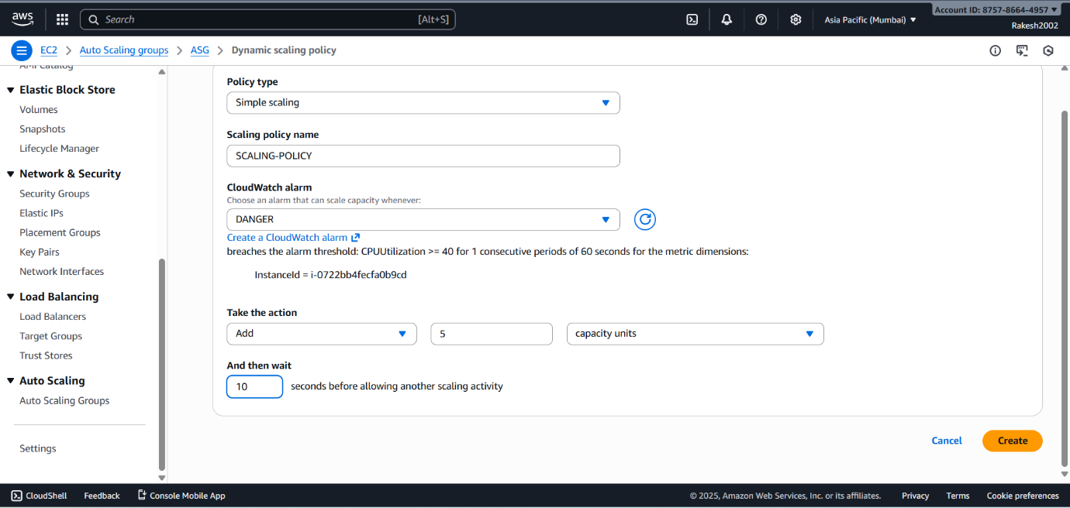

**STEP 25:** **Access the webpage though the load balancer DNS.**

